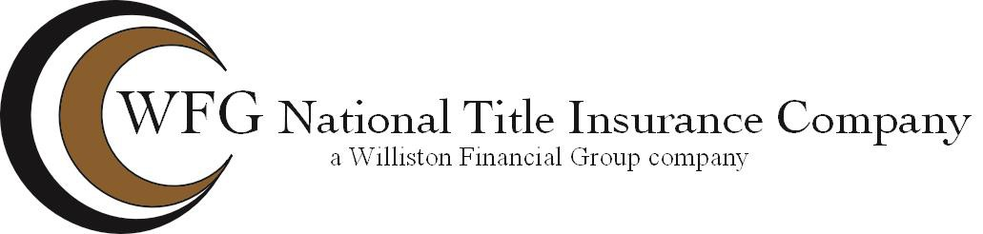

ACCEPTANCE BY MECHANICS’ LIEN AGENT
(one or two family residential dwelling units only)

Brief Legal Description of Property:

located in the City /County of , Virginia.

The undersigned hereby consents to act as Mechanics’ Lien Agent (the “MLA”) for the owner(s) of the above described property for the purpose of receiving notices pursuant to Section 43-4.01 of the Code of Virginia.
The MLA agrees to perform those acts required by Virginia Code Section 43-4.01 (D) and no further duties are assumed or shall be deemed to be assumed by the execution by the MLA of this Acceptance.

(MLA)

BY:
Printed Name: Title:
Date: MLA’s File/Reference No.

